Smoothie Seminar
By
Chef Coral

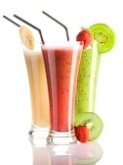
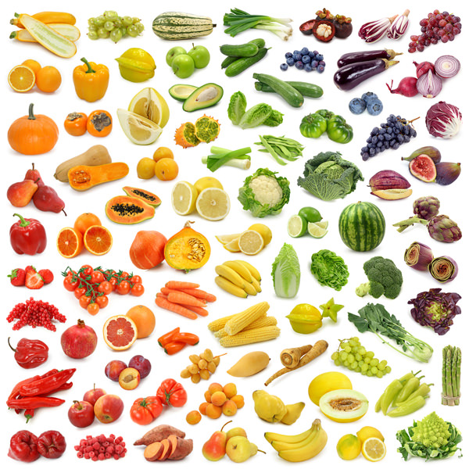

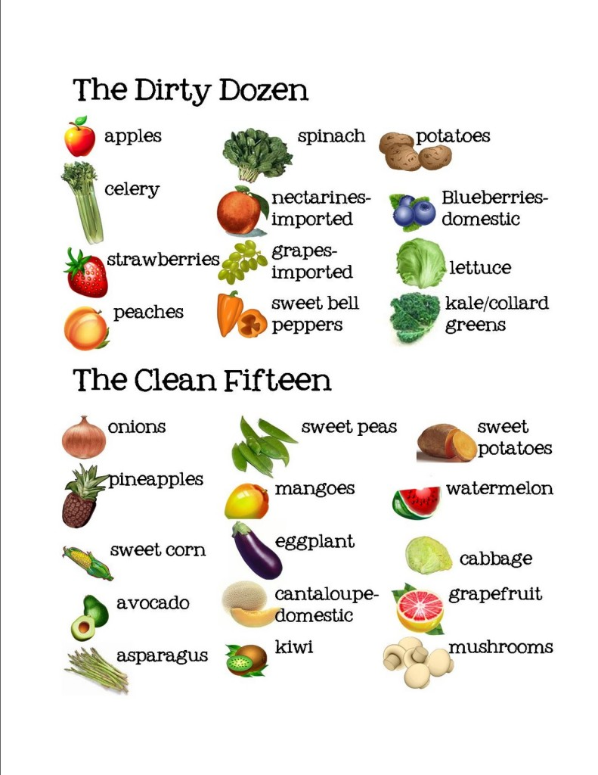

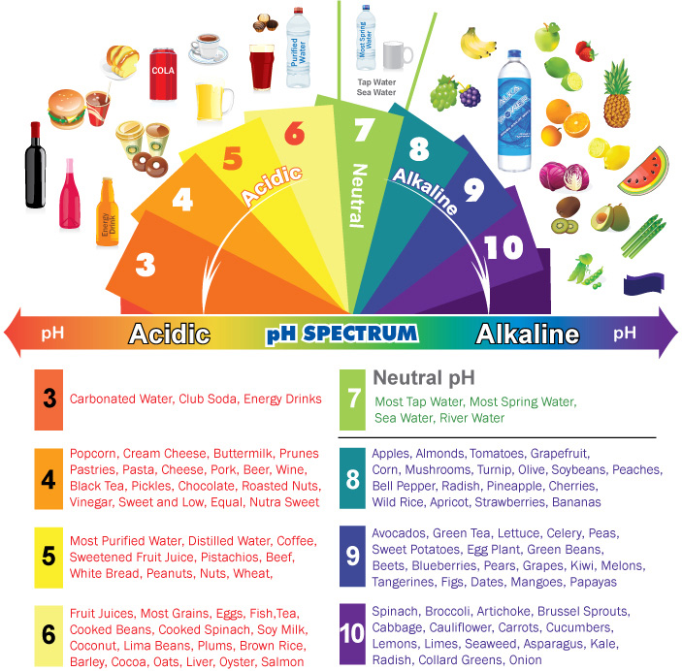

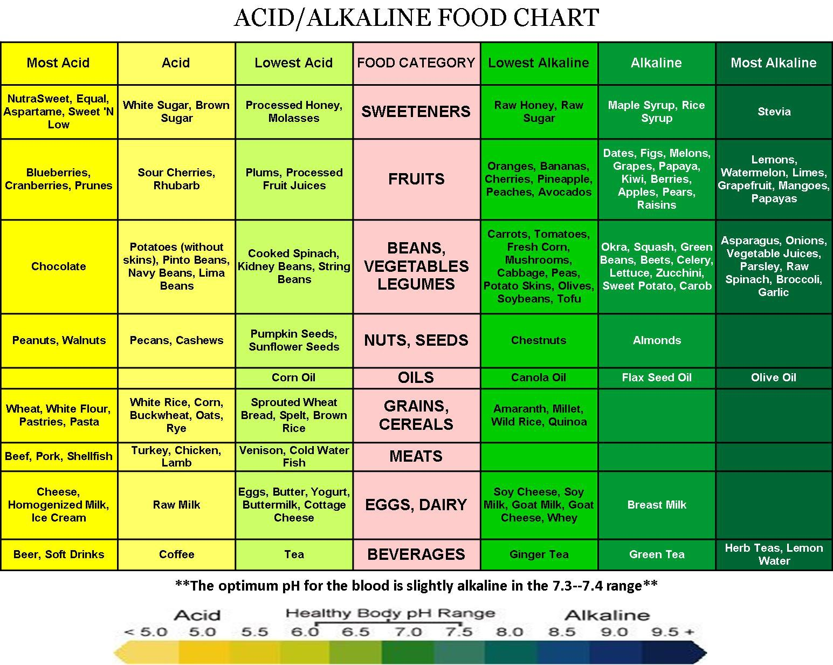

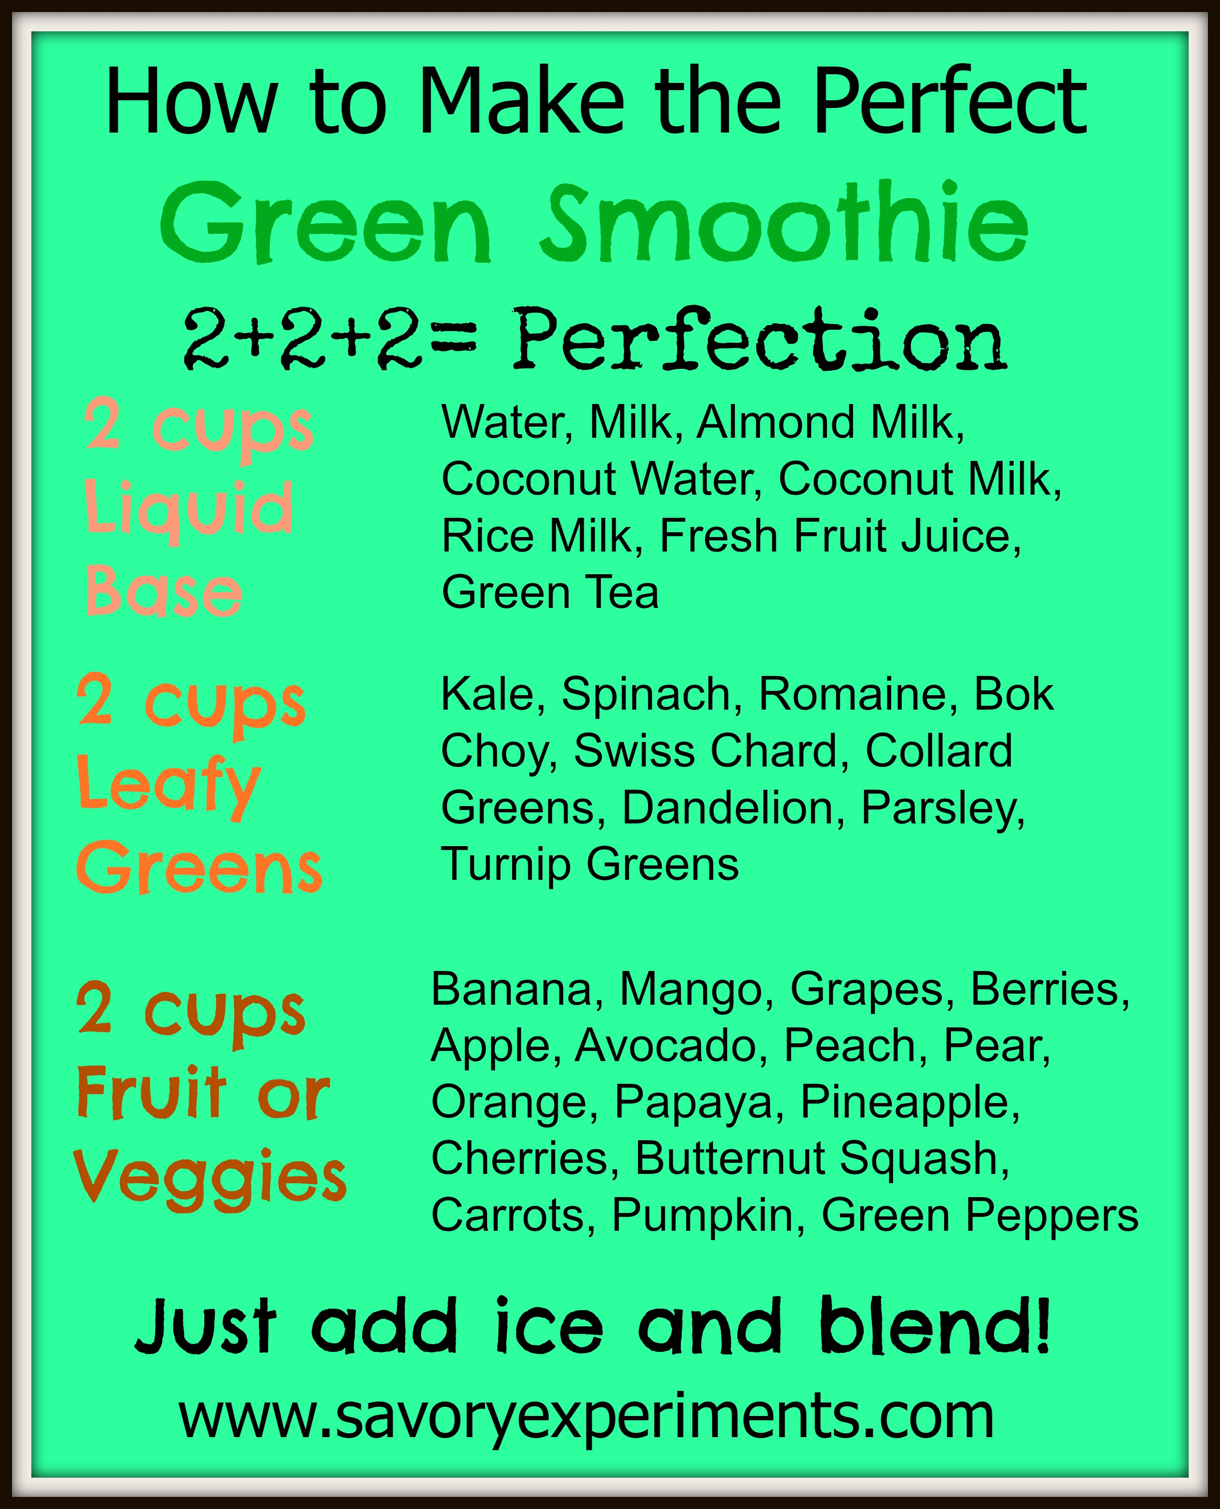

“Tropical Delight”
Yields 3 cups

Pineapple is a rich source of bromelain, an enzyme that helps to break down proteins and has anti-inflammatory properties. The fruit is actually made of many individual berries that fuse together around a central core. Each pineapple scale is an individual berry. Pineapples’ nutritional benefits are as fascinating as their anatomy as they contain high amounts of vitamin C and manganese.

- 5 medium apples
- 2 large handfuls of spinach
- 1 bunch of fresh mint, stems removed
- ½ large pineapple peeled
- Freshly squeezed juice of 1 lime

Put one apple piece in the chute of the juicer, followed by some spinach, mint and a piece of pineapple. Turn the juicer on and push through. Follow with the remaining ingredients, then whisk in the lime juice.
This juice has been an instant winner to all who have tried it.

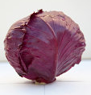

“Color Purple”
Yields 3 cups

Cabbage can provide you with some special cholesterol-lowering benefits. Red cabbage has added nutritional benefits plus a robust hearty flavor. The rich red color of red cabbage reflects its concentration of anthocyanin polyphenols, which contribute to red cabbage containing significantly more protective phytonutrients than green cabbage. Cabbage is also known to have antioxidant and anti-inflammatory properties.

- 2 cups red cabbage shredded
- 1 cup of blueberries
- 2 teaspoons Chia seeds soaked for 10 minutes in 8 oz. water
- 2 bananas frozen

Place all of the above items in a blender on high until smooth. Expect to be amazed by the thick cool creamy purple concoction!
This smoothie will continue to thicken because of the chia seeds so just give it a quick stir if it sits for a while.

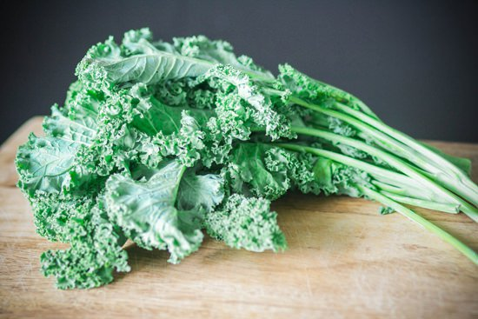

“Green Dream”
Yields 3 cups

If you have not tried kale yet, now may be the time. This super green is packed to the max with nutrition that puts it high on the list of the world's healthiest foods. Here are some health benefits of kale that are supported by science.
- Kale is Among The Most Nutrient Dense Foods on The Planet
- Kale is Loaded With Powerful Antioxidants
- It is an Excellent Source of Vitamin C
- Kale Can Help Lower Cholesterol
- Kale is High in Lutein
- Kale is One of The World’s Best Sources of Vitamin K

- 1 cup firmly packed kale
- 1 cup soymilk or nut milk
- ½ pear, frozen
- ½ banana, frozen
- 1 Tbsp. almond butter

Place all the above ingredients in a blender, blend on high until smooth & creamy. You will not believe something so packed with nutrition can taste so good.
Enjoy daily.

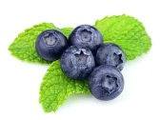

“Antioxidant Blast”
Yields 7 cups

Blueberries – Small in size, big in flavor and goodness, blueberries are ladened with antioxidant nutrients such as vitamins A and C, as well as bioflavonoids. They yield a rich, sweet flavor and give a blended drink blue specks. The berries are good for overcoming bladder problems, as well as boosting immunity and protecting the eyes and blood vessels. Blueberries are one of the best sources of salicylate, a natural aspirin-like compound that has been shown to reduce inflammation.

- 3 cups pineapple juice
- 9 oz. blueberries (2 small packs)
- 2 frozen bananas
- 12 ice cubes
- Mint sprigs to garnish

Place the pineapple juice, blueberries, bananas, and ice cubes in a blender and blend until slushy. Pour into glasses and serve. Garnish with a mint leaf.
A sure way to chase your “blues” away!

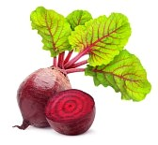

“Can’t Beet It”
Yields 2 1/3 cups

Beets (beetroot) The wonderful juice of the beet has a distinctly “soily” taste to it. This earthiness gives a hint of a very rich mineral and vitamin content, and as such, beets are known to be the best cleansing, blood-boosting tonic-like juice there is. Juice the greens to if you can get a hold of them, as they add an even greater health dimension.

- 2 medium size beets washed unpeeled
- 2 ribs of celery
- 2 medium size apples
- ½ to 1” fresh ginger peeled

As you feed these vegetables through the chute of the juicer alternately you will be amazed at the brilliant, vivid red color not to mention the invigorating taste!

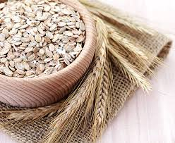
“Breakfast on the Go”
Yields 5 cups

Oats – have many health benefits, they lower cholesterol levels with their high fiber content and act as antioxidants to help prevent free radicals. Oats also enhance Immune response to infection and help stabilize your blood sugar. Oats will substantially lower your risk for Type 2 Diabetes while filling you up and keeping you satisfied longer.

- 6 Tbsp. oats soaked in ½ cup apple juice for 10-15 minutes
- 2 Tbsp. Pecans, plus 1 Tbsp. chopped for garnish
- 2 bananas frozen
- 2 cups soymilk or nutmilk
- 6 Ice cubes

Mix the oats, nuts, bananas, soymilk and ice cubes in a blender and blend until you have a smooth texture.

Pour into glasses and sprinkle with the chopped Pecans. This smoothie has a rich creaminess that will satisfy you and make you want another one again tomorrow!

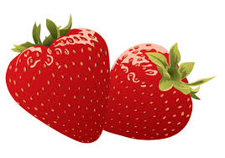

“Lite & Luscious”
Yields 2 cups

Strawberries – The only fruit to have their seeds on the outside, strawberries contain high levels of vitamin C and soluable fiber that helps break down “bad” cholesterol in the body. Strawberries are also high in disease-fighting phytochemicals. Strawberries contain powerful antioxidants that work againt free radicals, inhibiting tumor growth and decreasing inflammation.

- ¾ cup quartered fresh strawberries
- ¾ cup unsweetened apple juice
- ½ cup frozen unsweetened raspberries
- 1 frozen bananna

Combine all the ingredients in a blender. Blend until smooth. This beautiful pink drink gives mega flavor and is naturally low in calories.

