Media Release

Name of Student
Name of School
School Year

This is to certify that I give permission to photograph and/or videotape my student for use on [the school’s] website, in various school publications, and in printed media. I understand that all rights, title, and interest in the photography for said media outlets belong to [the school] and that I will receive no financial compensation for the use of these pictures and/or videotape. I further understand that [the school] may edit, copy, alter, or revise the photographs and/or videotape for use in its media outlets and that [the school] will retain control over the use and distribution of the photographs and/or videotape. I have read this form and I understand its meaning.

____________________________________________
Signature of student’s legal guardian or representative

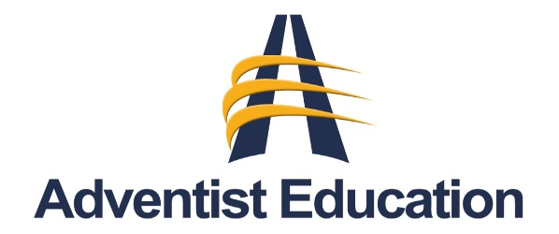
Northern California Conference
Office of Education
PO Box 619015
Roseville CA 95661

